DIY Ventures Customer Narrative Document

1. Purpose of This Document
This document provides the product and implementation team with the full client context needed to take over DIY Ventures after sales handover.
Website : https://www.packsecure.com.my/pages/about-packsecure
It combines:
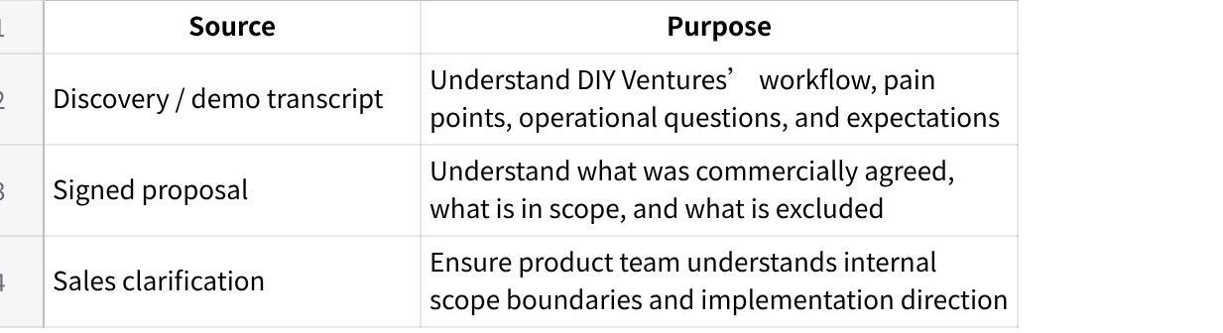
Click the image to view the sheet.
Important clarification: DIY Ventures uses AutoCount. Product team should treat AutoCount as the accounting, billing, document, order, customer, stock, and pricing reference system for this project.

2. Client Snapshot
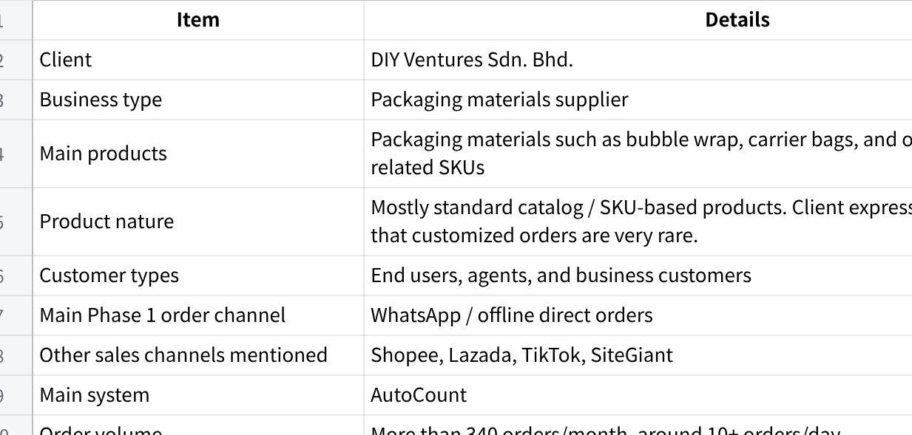
Click the image to view the sheet.
DIY Ventures’ core issue is that they receive messy WhatsApp orders, manually interpret them, prepare sales/billing documents in AutoCount, coordinate delivery by district/area, and only proceed once the delivery arrangement is clear. The signed proposal positions MAIA as a message-based order-processing layer with document preparation, delivery grouping, billing hold/status, and backend tracking.

3. Business Context
DIY Ventures sells packaging materials. The call clarified that they have their own catalog and SKU list, and that customized orders are very rare. Their operating model is therefore closer to standard SKU-based repeat ordering, not custom product configuration.
MAIA should be designed primarily around:
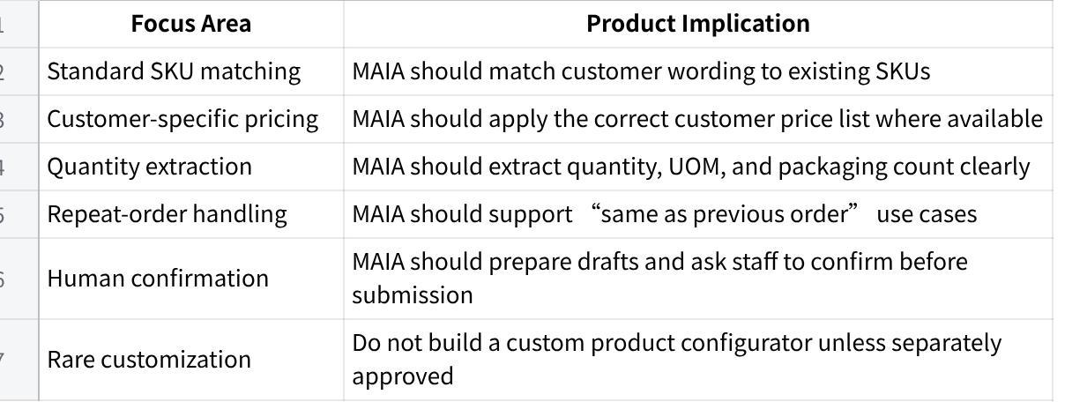
Click the image to view the sheet.
They sell to both:
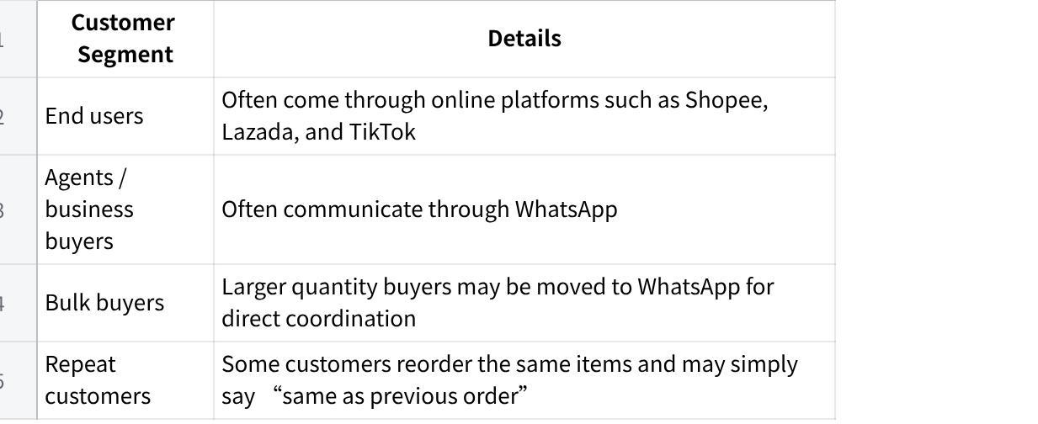
Click the image to view the sheet.
Important for product team: Phase 1 should focus on WhatsApp / offline direct orders. Marketplace automation is not part of the signed scope.

4. Current As-Is Workflow

4.1 High-Level Current Flow
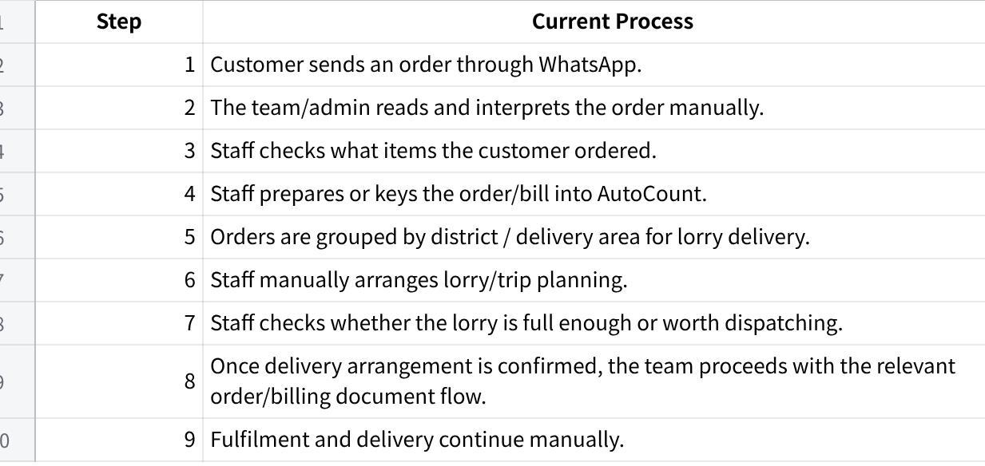
Click the image to view the sheet.

4.2 Important Operating Detail
DIY Ventures’ order flow is closely tied to delivery readiness. They do not only think in terms of “receive order → issue document.” They also need to know whether orders can be grouped into a delivery trip and whether the lorry is worth sending out.
However, the signed scope is not for delivery optimization. MAIA is only expected to support:
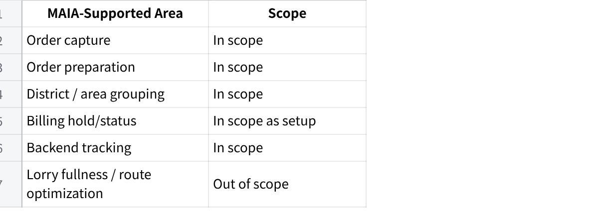
Click the image to view the sheet.
The proposal explicitly states that lorry full-load planning is out of scope and that MAIA will not calculate whether a lorry is full, optimize load capacity, plan routes, or decide dispatch readiness based on lorry utilization.

5. Main Pain Points
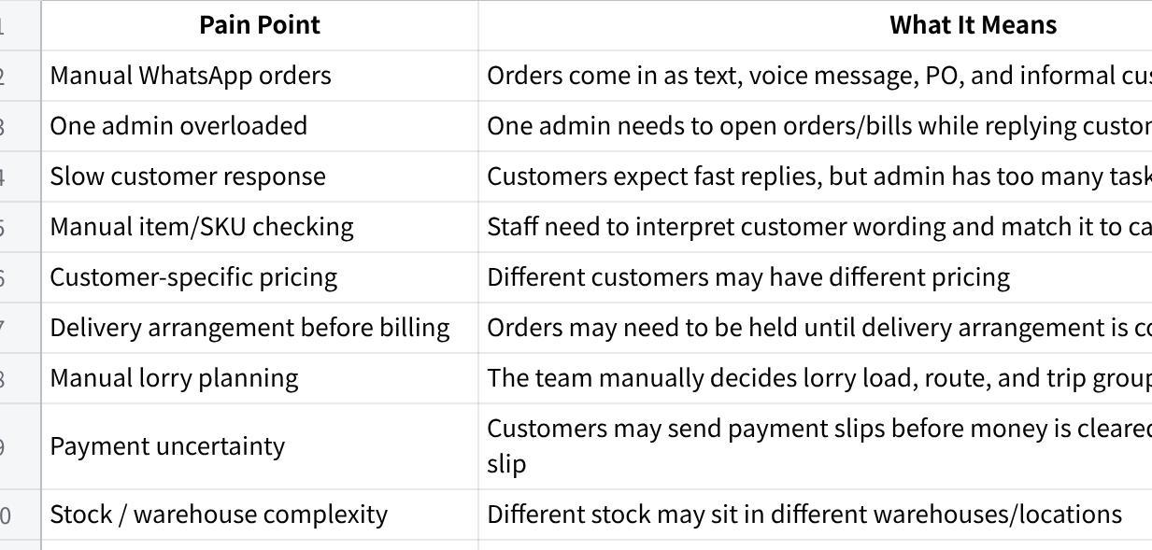
Click the image to view the sheet.

6. Products / Item Understanding
DIY Ventures sells packaging materials and has its own catalog and SKU list. The client expressed during the call that their orders are mostly standard catalog/SKU-based orders, and customizations on the order are very rare. This means MAIA should primarily be designed around standard SKU matching, customer-specific pricing, quantity extraction, and repeat-order handling, rather than custom product configuration.
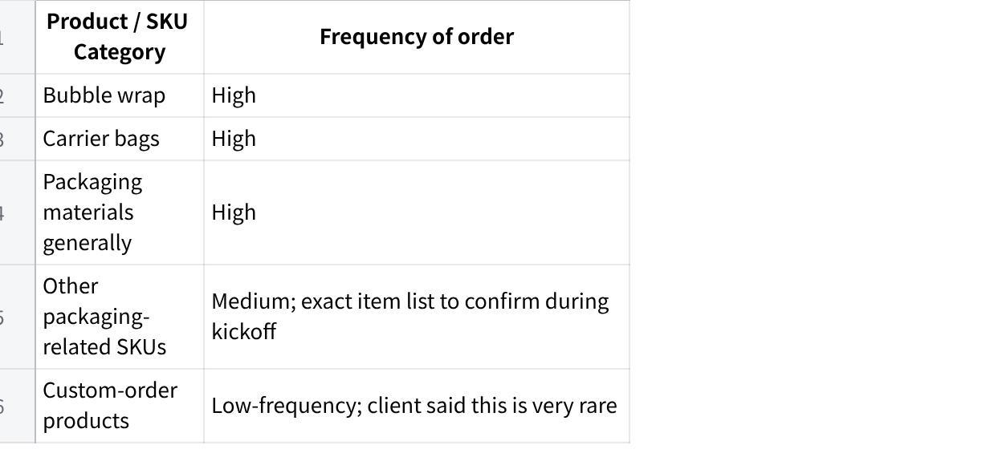
Click the image to view the sheet.

Product Data Required
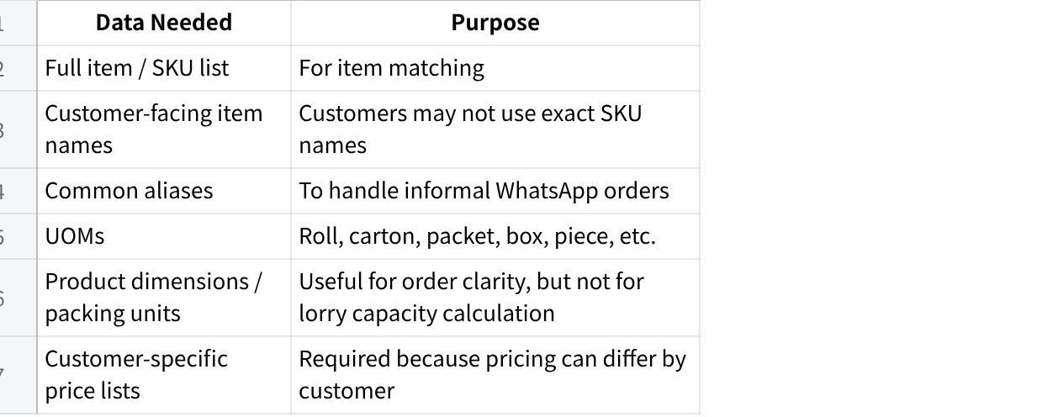
Click the image to view the sheet.

7. Customer Types and Buying Behavior
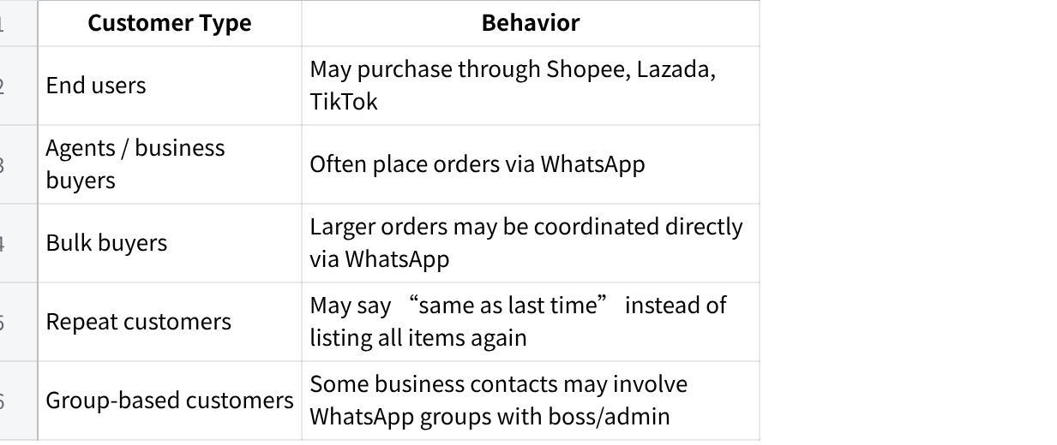
Click the image to view the sheet.

Important Use Case: Repeat Order
Customer may say:
“Same as previous order.”
Expected MAIA behavior:
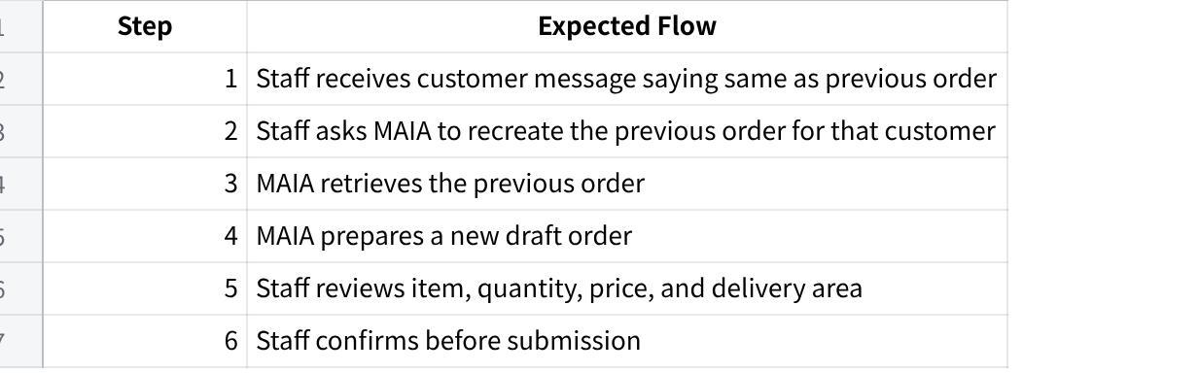
Click the image to view the sheet.
Do not auto-submit repeat orders without human confirmation.

8. Order Intake Details

8.1 Order Formats
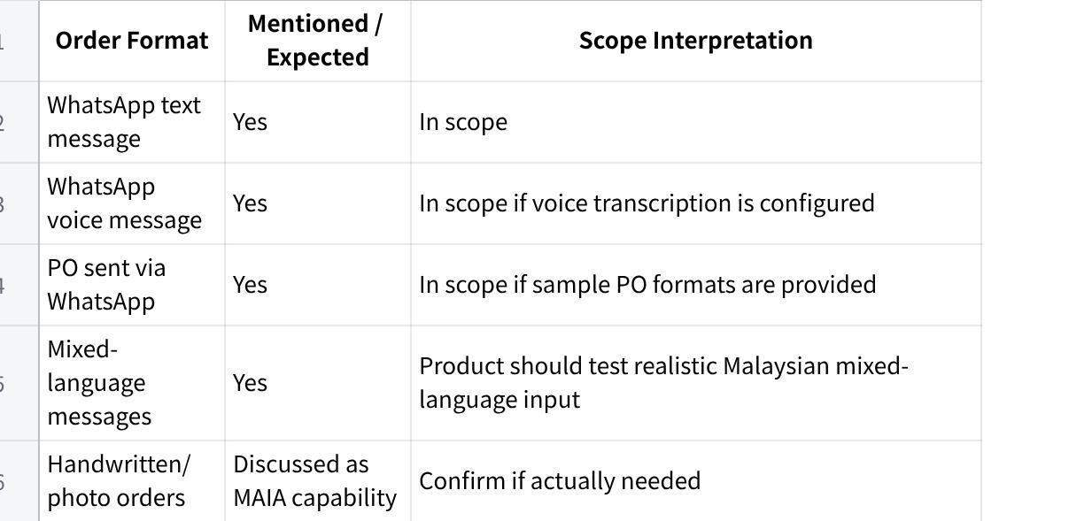
Click the image to view the sheet.
The client mentioned that some customers prefer voice messages, especially Chinese-speaking customers. Product should collect real examples of text, voice, and PO orders.

8.2 Language Considerations
Product should expect WhatsApp orders in:
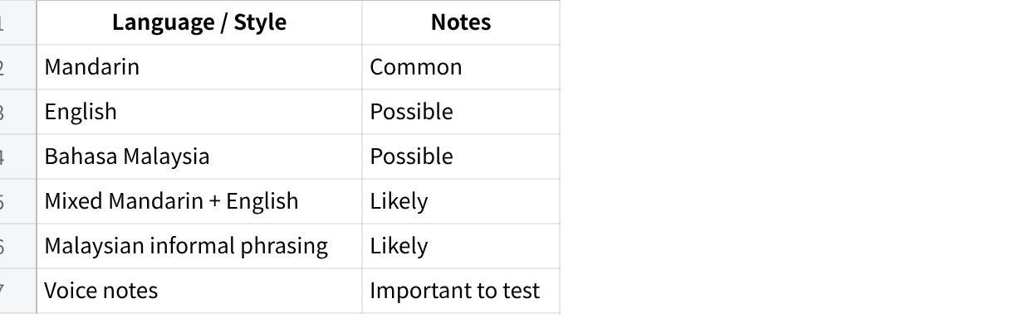
Click the image to view the sheet.

9. Systems and Tools
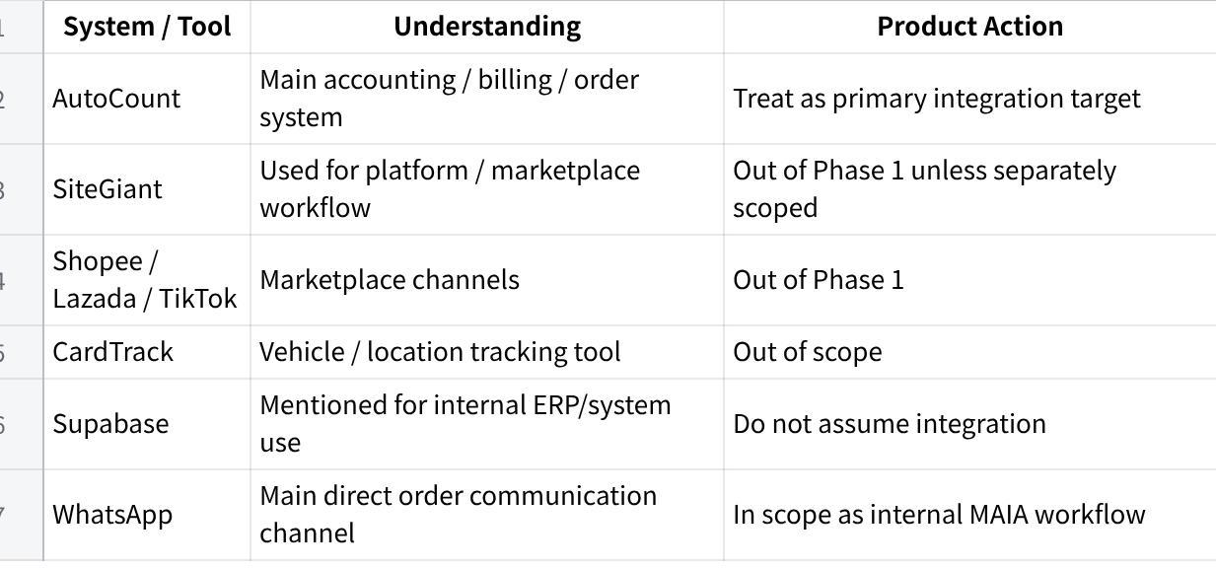
Click the image to view the sheet.
Important: Use AutoCount only in all product planning and documentation.

10. Proposed MAIA Role for This Client

10.1 Phase 1 Positioning
MAIA should be treated as an internal order-processing assistant, not a customer-facing chatbot.
The intended Phase 1 role:
Staff forwards or inputs WhatsApp orders into MAIA. MAIA extracts order details, checks customer/item/pricing/stock/credit where data is available, prepares a draft order or billing document, asks staff to confirm, then helps create the agreed document/workflow record in AutoCount or AutoCount-style format.

10.2 What MAIA Should Do in Phase 1
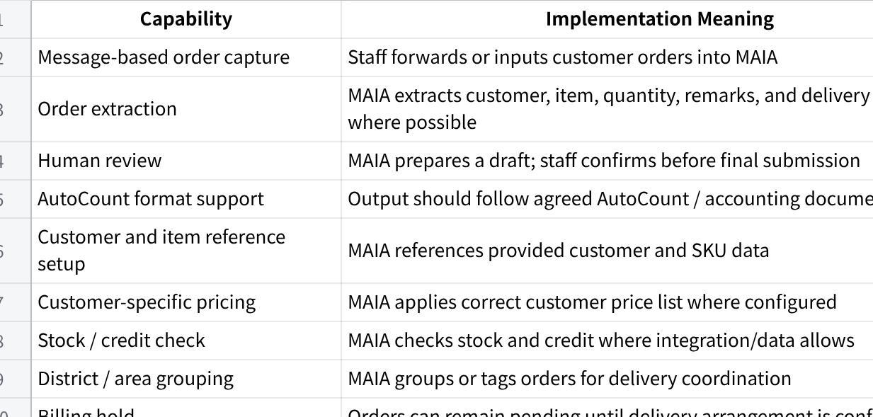
Click the image to view the sheet.
The signed proposal includes message-based order capture, order extraction, staff review, document generation in DIY Ventures’ accounting format, delivery grouping, backend order tracking, billing hold setup, activity trail, and backend workspace visibility.

11. Signed Scope and Commercials
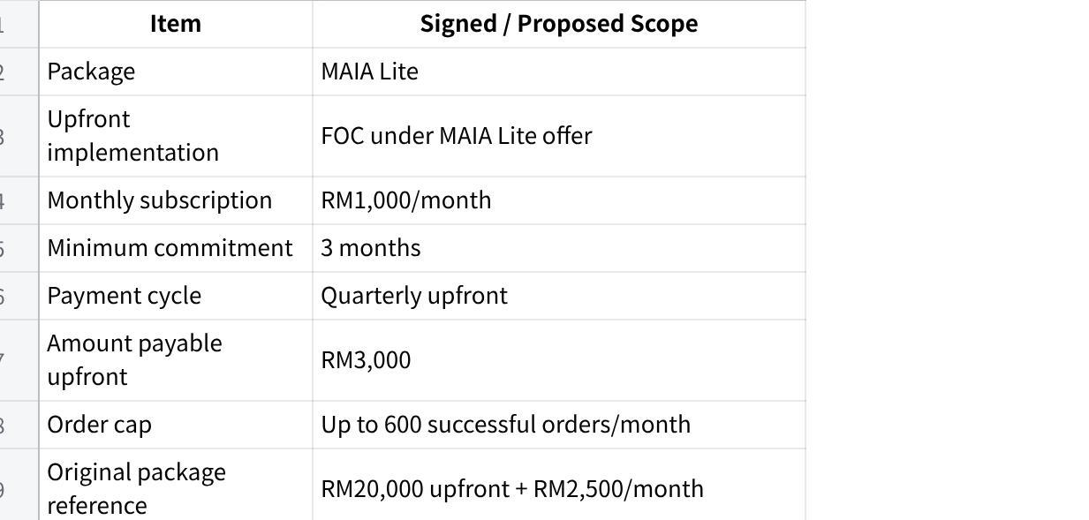
Click the image to view the sheet.
An order is counted only when the order is successfully created in the agreed system or workflow, not every message, draft, discussion, or enquiry. The proposal also states that external hosting/platform fees, WhatsApp API charges, vendor charges, and paid third-party tools are client responsibility where applicable.

12. In-Scope Items
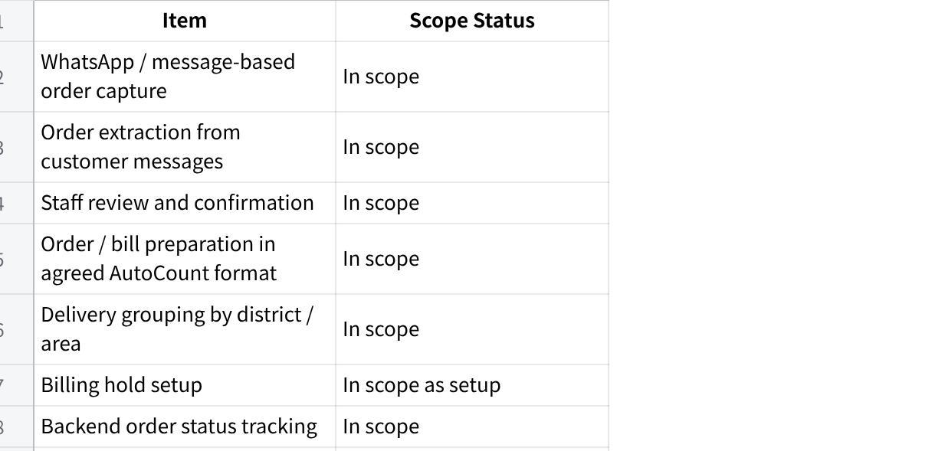
Click the image to view the sheet.

13. Out-of-Scope / Communicated Boundaries
The items below were either clearly excluded in the signed proposal or communicated during the meeting as not included / not currently available / requiring separate technical discussion. Product team should be aware because the client raised these topics, but they should not be built under Phase 1 unless separately approved.
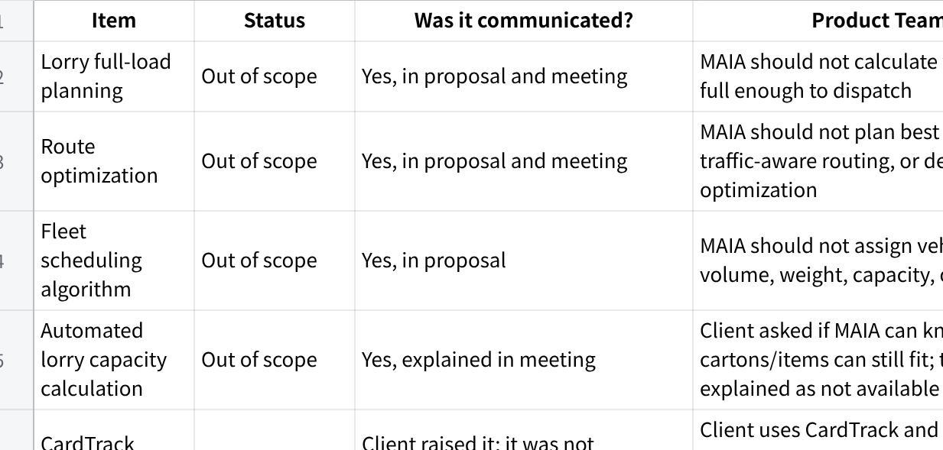
Click the image to view the sheet.
The signed proposal explicitly excludes lorry full-load planning, route optimization, fleet scheduling algorithm, driver app, GPS tracking, advanced custom dashboards, custom workflows outside MAIA Lite, and third-party vendor implementation.

Internal Instruction for Product Team
These items were raised during sales/discovery, so product team should not be surprised if the client brings them up again. The correct handling is:
“This was discussed as out of scope / future scope / requiring separate technical validation. Phase 1 will focus on the agreed MAIA Lite workflow first.”

14. Important Workflow Clarifications

14.1 Sales Order vs Invoice vs “Bill”
The client uses terms like “开单” / “bill,” but product team must verify the exact document flow.
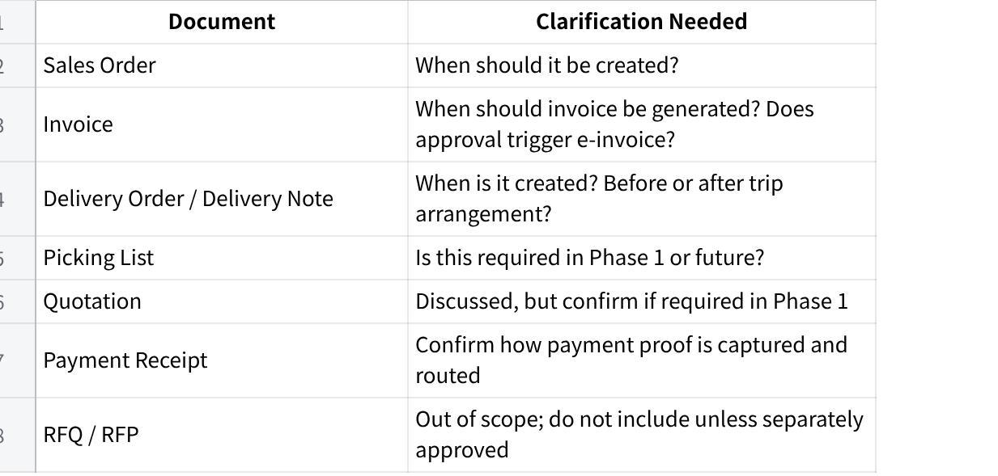
Click the image to view the sheet.

14.2 Recommended Phase 1 Flow
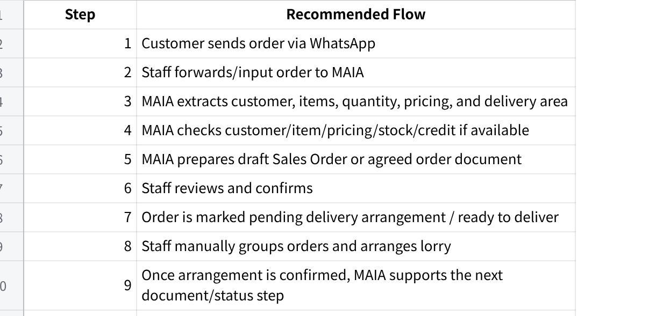
Click the image to view the sheet.

15. Payment and Finance Flow
The transcript revealed payment complexity.
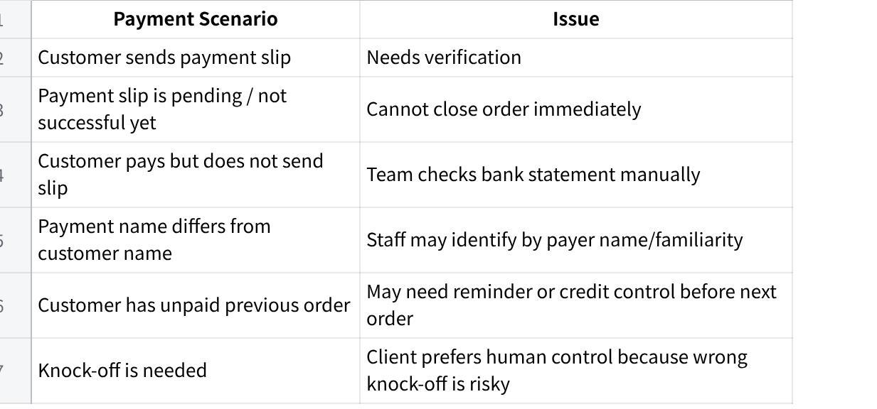
Click the image to view the sheet.

Product Recommendation
MAIA should not auto-knockoff payments in Phase 1.
Safe approach:
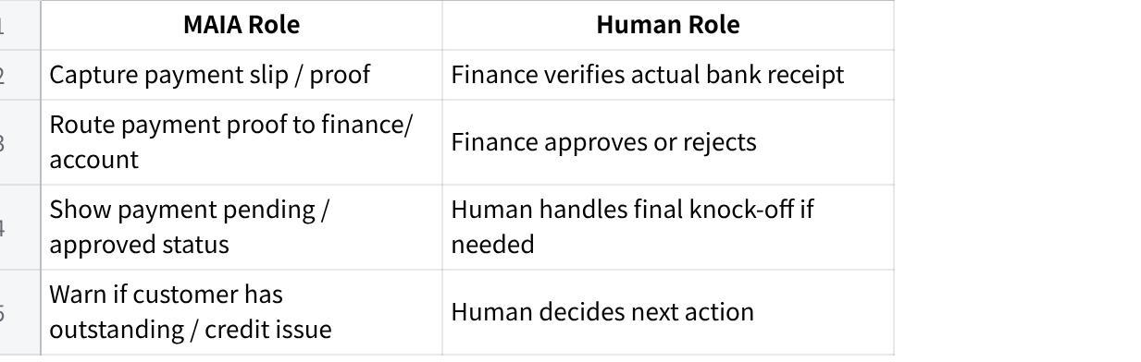
Click the image to view the sheet.
Auto finance knock-off was discussed and should remain human-controlled unless separately scoped.

16. Credit Control
Credit control is relevant.
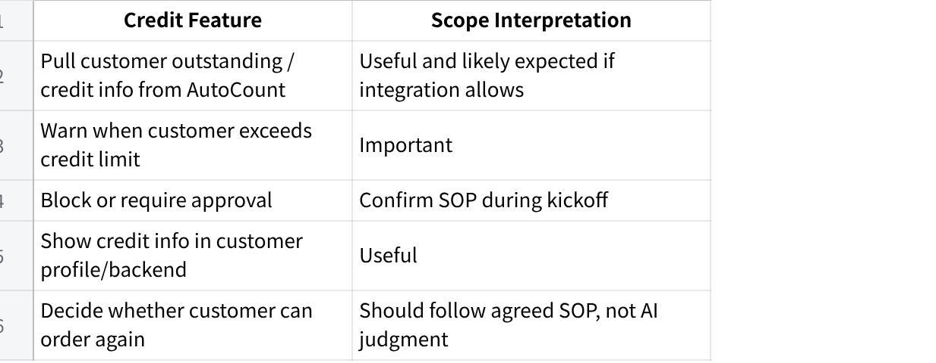
Click the image to view the sheet.

17. Stock, Warehouse, Picking, and Fulfillment
DIY Ventures has multiple stock locations / warehouses and different staff preparing different products.

17.1 What Was Discussed
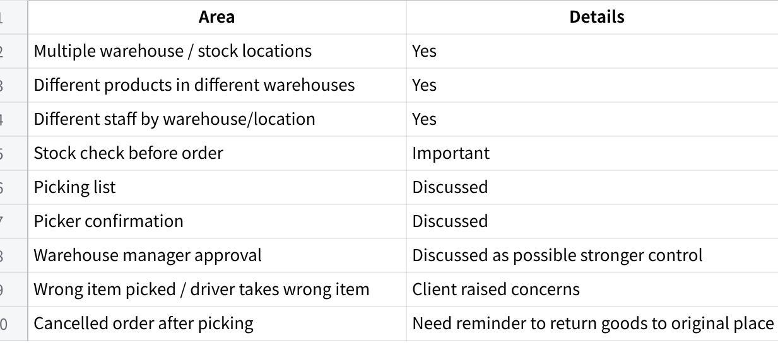
Click the image to view the sheet.

17.2 Product Boundary
Safe Phase 1:
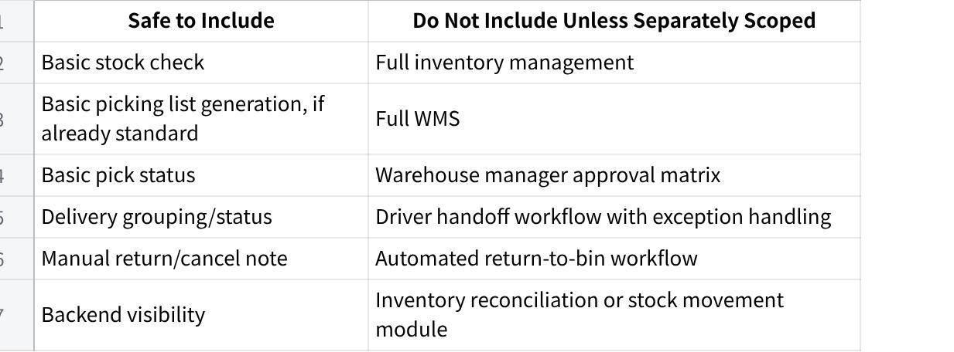
Click the image to view the sheet.
Product should clarify whether picking list is truly part of Phase 1 or only shown as general MAIA capability.

18. Delivery / Lorry Arrangement
DIY Ventures currently arranges deliveries manually, likely using Excel-style lists/columns. Orders may sit in an unarranged list, then be assigned to a lorry/trip once enough nearby orders are available.

18.1 What MAIA Can Support
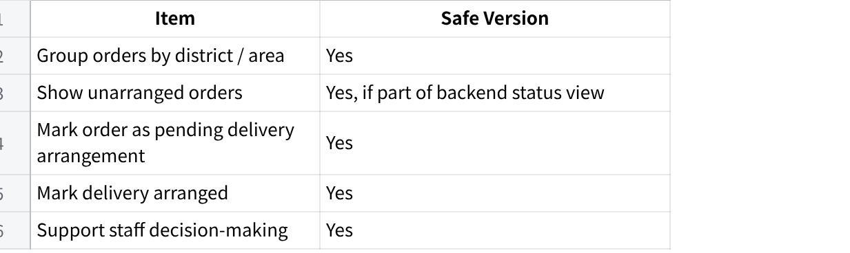
Click the image to view the sheet.

18.2 What MAIA Must Not Do
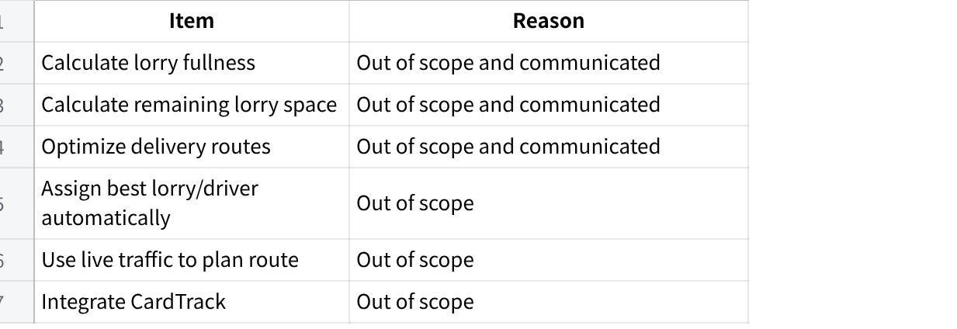
Click the image to view the sheet.

19. Multi-WhatsApp Number Situation
DIY Ventures may receive orders from multiple WhatsApp numbers, including company/admin/boss numbers.

Product Interpretation
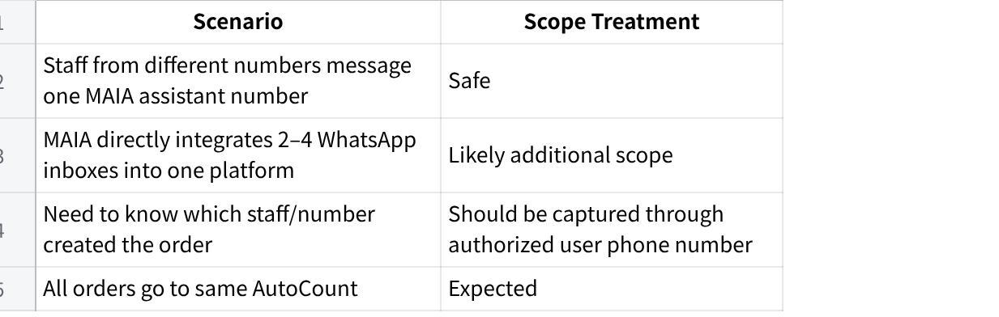
Click the image to view the sheet.
Phase 1 should use the simplest approach unless product confirms multi-inbox capability is standard:
One MAIA company assistant number. Internal staff forward/input customer orders into MAIA. MAIA records which authorized staff number initiated the instruction.

20. Customer-Facing vs Internal-Facing
Jeremy positioned MAIA as internal-facing first. This is important.
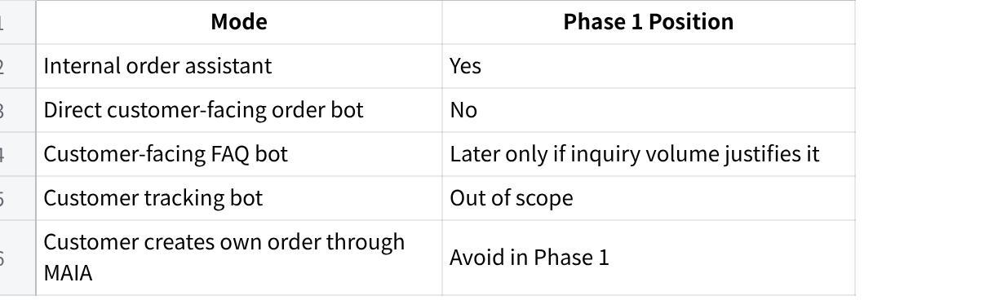
Click the image to view the sheet.
Reason: if customers directly create orders that DIY Ventures cannot fulfill, it creates operational and customer service risk.

21. Quotation / RFQ / RFP
Quotation functionality was discussed, but RFQ and RFP workflows are out of scope.
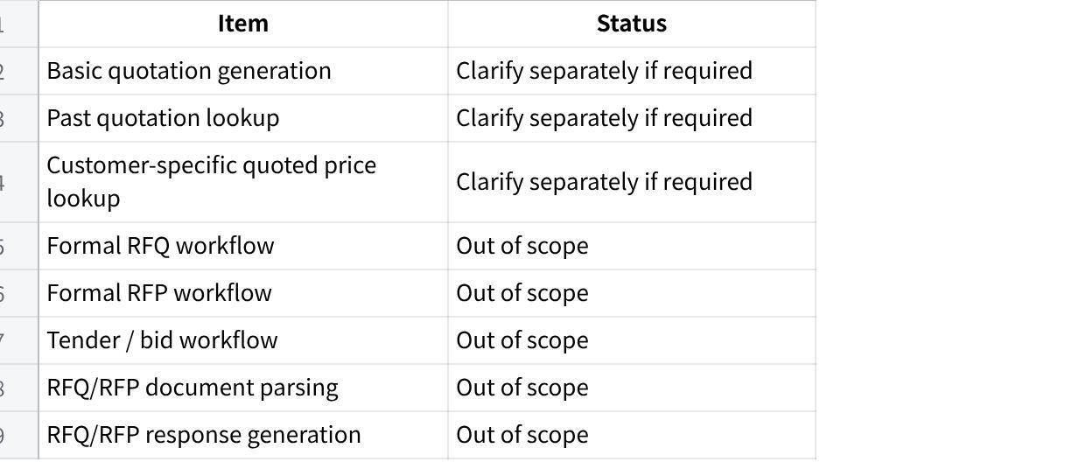
Click the image to view the sheet.
Product should not design Phase 1 around RFQ/RFP. If the client later brings up RFQ, RFP, tender, bid submission, or formal quote comparison workflows, product should route it back for separate scoping.

22. Hosting / Deployment
MAIA should be hosted/deployed in DIY Ventures’ environment.
This was discussed during the call, where it was explained that MAIA would be deployed within their server / cloud infrastructure, and that cloud or infrastructure-related costs would continue to be borne by DIY Ventures through their own cloud/environment provider.
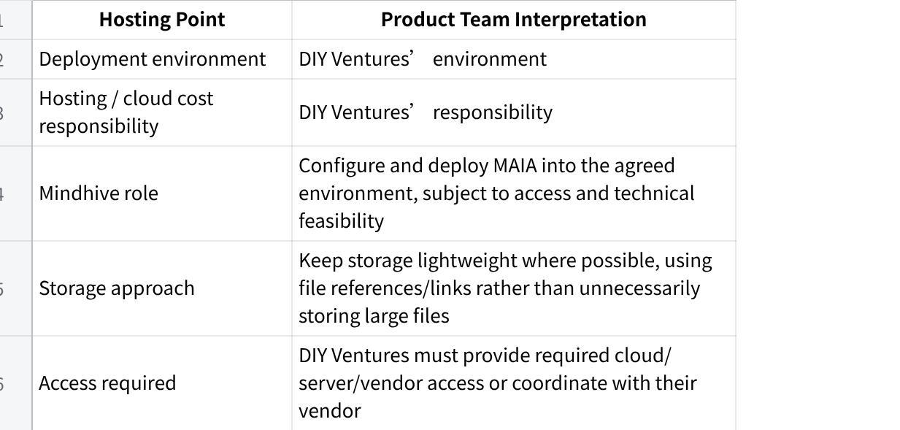
Click the image to view the sheet.
Product team must clarify during kickoff:
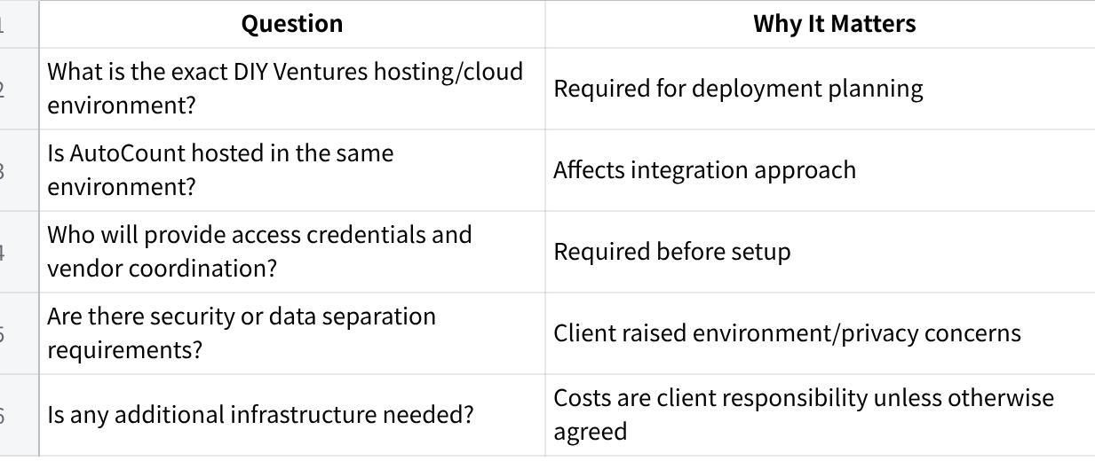
Click the image to view the sheet.

23. Data Required Before Build
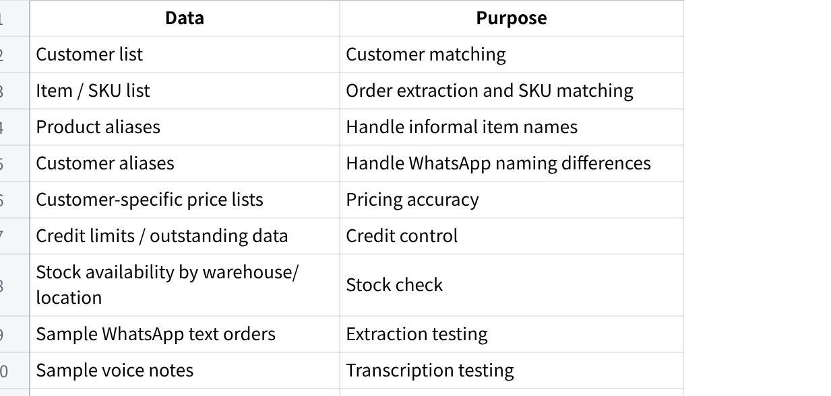
Click the image to view the sheet.

24. Suggested UAT Scenarios
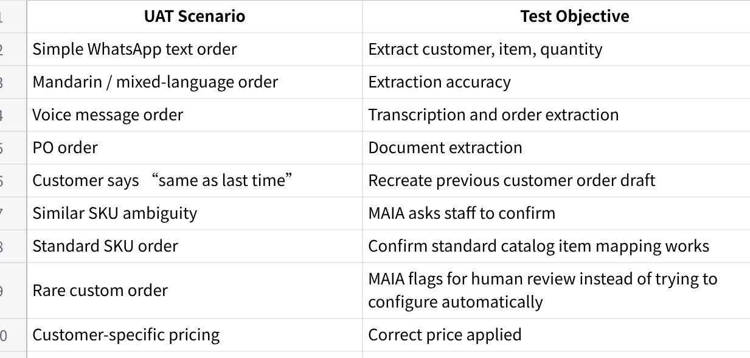
Click the image to view the sheet.

25. Key Risks for Product Team
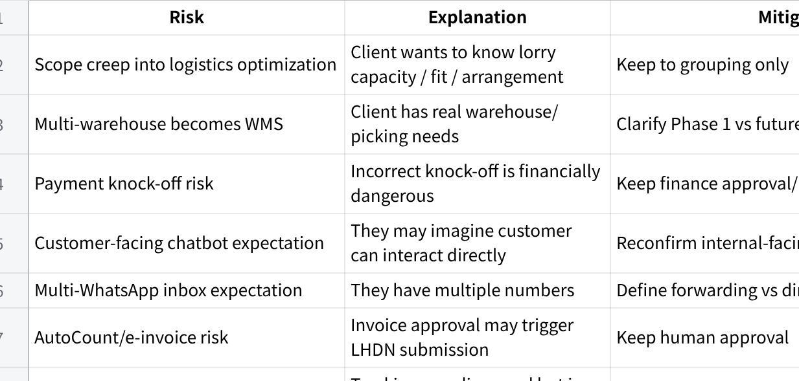
Click the image to view the sheet.

26. Product Team Recommendation
Implement Phase 1 as a message-to-order and billing-preparation workflow, not as a logistics, warehouse, finance, RFQ/RFP, customer-facing, or custom product automation project.

Recommended Phase 1 Build Focus
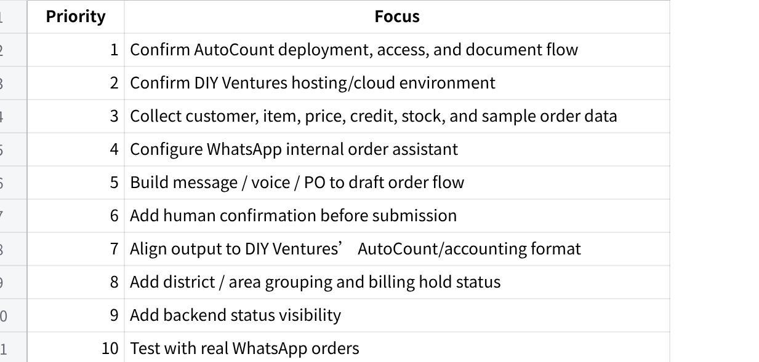
Click the image to view the sheet.

27. One-Line Product Summary
DIY Ventures is a packaging materials business that receives higher-volume direct orders through WhatsApp and manually converts messy text/voice/PO orders into AutoCount-style sales/billing workflows. Their orders are mostly standard catalog/SKU-based orders, with custom order requirements being very rare. Phase 1 should help internal staff capture orders, extract items, apply customer/item/pricing references, support district/area delivery grouping and billing hold status, and track backend progress. MAIA should be hosted in DIY Ventures’ environment, while lorry capacity planning, route optimization, CardTrack tracking/integration, customer-facing automation, marketplace orders, RFQ/RFP workflows, direct LHDN submission, auto finance knock-off, full WMS, and custom product/order configuration remain outside the signed scope unless separately approved.

